# 

Statement of Work

Bots & Conversational AI

JCI HR Bot Feature Update

Prepared for

Johnson Controls

Prepared by

Brad Lawrence, Architect

Date: May 24, 2019

Version: v1.4

Table of contents

Introduction 2

1. Project objectives and scope 2

1.1. Objectives 2

1.2. Areas in scope 4

1.3. Definition of done 12

1.4. Areas out of scope 13

2. Project approach, timeline, and deliverable acceptance 14

2.1. Scrum approach 14

2.2. Timeline 20

2.3. Deliverable acceptance process 20

2.4. Project governance 21

2.5. Project completion 22

3. Project organization 22

3.1. Project roles and responsibilities 24

4. Customer responsibilities and project assumptions 26

4.1. Customer responsibilities 26

4.2. Project assumptions 27

This Statement of Work (SOW) and any exhibits, appendices, schedules, and attachments to it are made pursuant to Work Order 6Y02194-234426-275054 and describes the work to be performed (services) by Microsoft (“us,” “we”) for JCI (“Customer,” “you,” “your”) relating to HR Bot Update (project).

This SOW and the associated Work Order expire 30 days after their publication date unless signed by both parties or formally extended in writing by Microsoft.

Introduction

Microsoft will use its global experience, combined with a wide array of Services, to deliver integrated conversational artificial intelligence (AI) solutions on its scalable and more secure Azure cloud-based platform. The ability to deploy the fundamental components of an intelligent omnichannel experience (starting with a web channel), together with business applications (such as Microsoft Office), cloud, AI, and developer process innovation positions Microsoft as a leading choice to deliver JCI’s conversational AI project

Microsoft offers core technologies that can be used to build and deliver a wide range of Bots & Conversational AI such as:

* Application development using an agile approach and using Azure DevOps Services
* Conversational applications (or bots) development using the Microsoft Bot Framework, Microsoft AI, and Microsoft Azure
* A comprehensive set of flexible AI services for any scenario and enterprise-grade AI infrastructure that runs AI workloads anywhere at scale.
* A comprehensive conversational applications analytics platform that the Customer can use to continually monitor and improve the Solution to meet business goals.
* A knowledge extraction and data ingestion pipeline that can be used to transform information for rich, context-driven conversations.
* Microsoft Azure platform as a service (PaaS) and infrastructure as a service (IaaS), which can be used to support the Solution

This SOW outlines the work to be performed in order to design and develop a minimally viable conversational AI solution [or minimum viable product (MVP)] for JCI through the use of the Microsoft Bot Framework and the Microsoft AI platform.

# Project objectives and scope

## Objectives

The objective of this project is to engage collaboratively with JCI to envision and deliver an AI-based conversational application (or bot) that will facilitate the delivery of context-aware automated responses to common inquiries.

This conversational application (or bot) will be delivered in a phased delivery approach to provide a Minimum Viable Product (MVP) and will be deployed in nonproduction development and test environments. The MVP will be developed to use JCI’s existing QnAMaker databases and provide the additional reporting and telemetry features they have requested.

Beyond the initial scope and design of the Conversational AI solution, we will be collecting a limited backlog of items for the future roadmap of the application.

## Areas in scope

### General project scope

This is a fixed duration and fixed capacity engagement with *variable scope*. This is *not a fixed fee and scope engagement* with fixed deliverables. The Conversational App scenario delivered in the solution is required to be conducted within the duration and delivery resource capacity of the engagement.

We will start with a project kickoff session focuses on the desired end state for the. We will explore the current experience and its alignment with JCI’s objectives and strategy. The MVP will follow our proven reference architecture and design for bots.

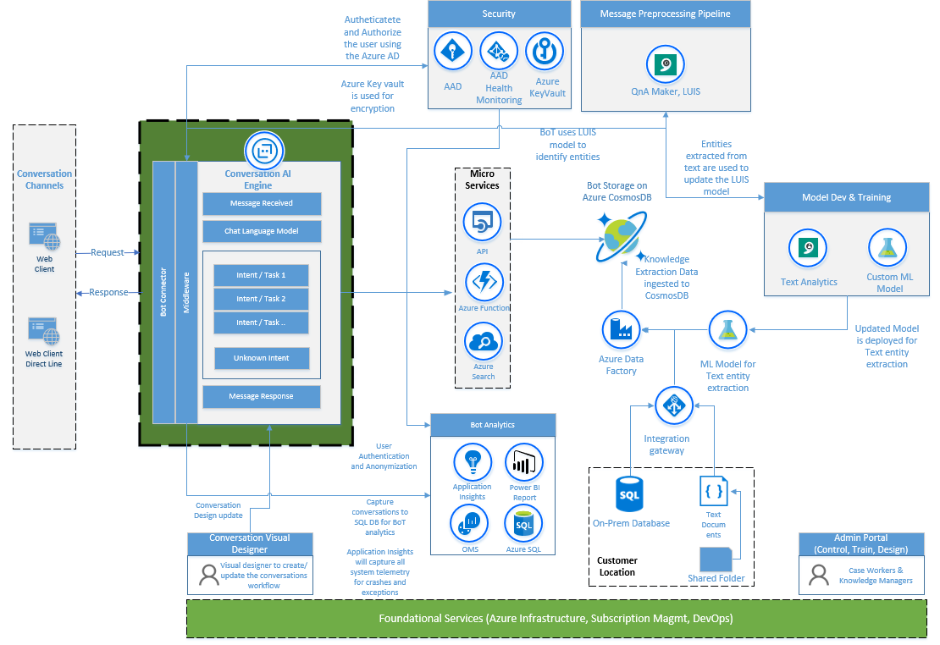

Microsoft will develop a Conversational AI Bot that provides the following capabilities for a deployment to development, test, and production environments:

* Connect to JCI’s existing QnAMaker model(s)
* Provide ability to get answers specific to the user’s role (requires support / integration form intranet site)
* Allow for the user to provide feedback through the bot
* Predefined bot analytics and reporting
  + Allow administrators to view bot performance through reports and dashboards
  + Allow administrators to see questions asked by the users
* Pre-defined bot template runtimes (Virtual Assistant template)

**This engagement makes use of a capacity-based agile development model.** The development capacity is limited to the hours and resources specified in the “Project Organization” section. Microsoft will only deliver the number of sprints and the scope that can be achieved with these resources and hours. Any scope or sprints that might not be completed within the hours and resources specified in the Project staffing section will be added to the change management process.

### A Production Ready MVP

Microsoft will develop an MVP that is based on the defined, internal facing (employee) experience or the external facing (customer) experience and the captured requirements as they were agreed upon during the kickoff meeting.

Note that Microsoft will complete the requirements for the MVP that are based on the effort allocated for the project. All elements not included in the MVP will be moved to a product backlog. A technical roadmap that can be used to move the MVP into production will also be included. The Conversational AI Bot will support the following capabilities.

| Capability | Architecture components |
| --- | --- |
| Conversation canvas | Anonymous or authenticated webchat or JavaScript SDK Direct Line bot client. |
| Conversation engine | * Configuration management * Message processing and dialog response |
| Bot analytics | * Application insights * Conversation logs * Power BI |
| Model development and training | * Knowledge: QnA Maker |
| Bot storage | * QnA Knowledge Base |
| Compute and data integration | * Azure Web Apps or Azure Functions |
| Foundational service | Azure DevOps Continuous Integration (CI) and Continuous Delivery (CD) |

### Software products and technologies

The products and technology that are listed in the following table are required for the project. JCI is responsible for obtaining all identified licenses and products.

| Product or technology item | Required by |
| --- | --- |
| One Azure subscription | At project start |
| Azure DevOps Service | At project start |
| Application insights | At project start |
| Power BI subscription | At project start |

This next list is subject to evolve during the engagement – products and technologies may be activated or removed to satisfy new or changes in requirements. Change management process will be followed as defined in this document for such scenarios.

| Operating Systems | Middleware | Data Stores | Development Languages | Provided by |
| --- | --- | --- | --- | --- |
| Microsoft Azure | * Bots and the Microsoft Bot Framework * Azure App Service * Cognitive Services * Application Insights/Power BI | * Azure Storage Account | C# | JCI |

### Data migration and sources

No data will be prepared or migrated as part of this SOW.

Knowledgebase information will be provided by JCI which will be ingested into Microsoft Azure to support the Bot.

### Integration and interfaces

No integrations will be done for this MVP.

### Environments

All environments used for development and test use of thesoftware, supporting systems, and development lifecycle will be supplied and maintained by the Customer.

JCI will provide an Azure subscription. The Customer will also provide Microsoft with enough administrative control to build the development and test environments.

The following environments will be required to deliver the project.

| Environment | Location | Responsible | Ready by |
| --- | --- | --- | --- |
| Development / Test (shared) | Azure | Microsoft | At of project start |
| Production | Azure | Microsoft | At project start |

### Testing

The following testing is included in the scope of the project.

| **Test type** | **Description** | **Responsibility** | | |
| --- | --- | --- | --- | --- |
| Has responsibility  for testing? | Provides data or test cases | Provides guidance and support |
| Unit | Testing of individual units or software components. The purpose is to validate that each unit of the software performs as designed. The developer conducts unit tests. | Microsoft | Customer | Microsoft |
| Integration | Testing of conversation dialog flow in order to verify that it meets specified requirements | Microsoft | Customer | Microsoft |
| System | Validation that system components are successfully deployed | Microsoft | Customer | Microsoft  The Customer will provide test data and flow context. |

## Areas out of scope

Any area not explicitly included in the Areas in scope section is out of scope for Microsoft during this engagement. Areas out of scope for this engagement are listed in the following table.

| Area | Description | |
| --- | --- | --- |
| Development of other intelligent experiences | Building and delivering others’ intelligent experiences outside of the Bot Framework and in a mobile or web apps are not included. |
| Product licenses and subscriptions | Product licenses (Microsoft or non-Microsoft) and cloud service subscriptions are not included. |
| Hardware | Microsoft will not provide hardware for this project. |
| Integration with third-party software | Microsoft will not be responsible for third-party software or APIs. |
| Data migration | Data migration activities are not in scope for this project. |
| System integration | System integration and interfaces are not in scope for this project. |
| Product bugs and upgrades | Product upgrades, bugs, and design change requests for Microsoft or non-Microsoft products are not in scope for this project. |
| Source code review | The Customer will not provide Microsoft with access to non-Microsoft source code or source code information. For any proprietary non-Microsoft code, Microsoft Services will be limited to the analysis of binary data, such as a process dump or network monitor trace. |
| Organizational change management | Designing—or redesigning—the Customer’s functional organization is not included. |
| Deployment, installation, configuration, and testing | The following items are not included:   * Installation and configuration of server hardware or network resources. * Installation, configuration, and testing of non-Microsoft software other than software identified as within scope and supported by Azure. * Testing and configuration of applications and Services outside of those required to support the deployment of the Solution. * Troubleshooting or remediation of existing network and storage systems. * Performance and load testing of application components and resources |
| Testing | Testing and configuration of applications and Services outside of those required to support the deployment of the Solution are not in scope. |
| Network and storage | Troubleshooting or remediation of existing network and storage systems is not in scope. |
| Labeled Data | Creation of labelled data for Machine Learning model training and testing |
| Data sources | Creation of a connector with custom enterprise data stores or third-party applications is not in scope |

# Project approach, timeline, and deliverable acceptance

## Scrum approach

### Sprint process

Microsoft will undertake an iterative development approach that is based on the Scrum process (<http://scrumguides.org> ), which is a fixed-duration, variable-scope process. The key tenets are:

* Joint ownership of decisions.
* Short implementation units (sprints).
* Prioritization of business objectives in a product backlog.
* Time-bound planning of each sprint.
* Emphasis on remaining work.
* Sprints that produce a functional solution.
* Sprint demonstrations that are time-restricted and have regular checkpoints for each sprint.
* Regular retrospective meetings that can be used for course correction.

Each of these activities is described in further detail later in this document and will be time-boxed to the noted total duration.

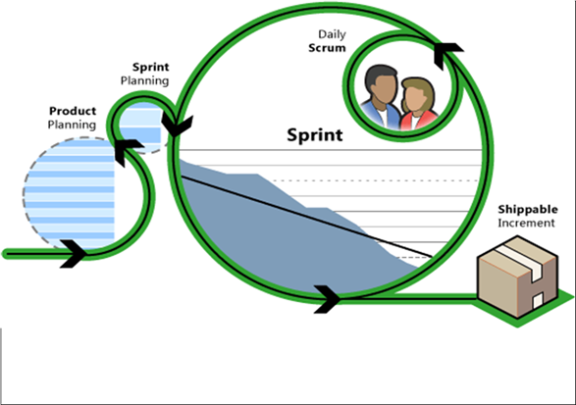

For each of the activities described in the following sections, the following Customer resources will attend and contribute, and will be empowered to make decisions:

* JCI project manager.
* JCI technical decision makers, such as architects.
* JCI business decision makers, such as product owners.
* User representatives such as users or proxies.

If additional Customer resources are required, those resources will be specifically listed in the following sections which describe the workshops.

### Delivery sprints

Following the previous activities, the development process will be initiated through development sprints for the conversational app MVP.

Each sprint will last one week; there will be a total of two sprints.

Before sprint planning starts, the Customer product owner will collaborate with Microsoft to create a proposed sprint scope.

During the sprint, the development team will build out the solution by the planned architecture. Standup meetings will be performed by the development team to keep everyone informed and to report any impediments. If the development team determines that a backlog item cannot be completed within the sprint duration, it will be deferred to a later sprint after consultation with the team and the Customer product owner. If the development team has extra capacity in a sprint, the development team will collaborate with the product owner to select backlog items to be added to the sprint scope. The development team is the sole decision maker on scope changes during the sprint.

The last day of the sprint is dedicated to demonstrating the functionality that has been achieved in the sprint and to carrying out a retrospective of the sprint. This is conducted in two parts:

* Sprint review: a sprint review meeting is held at the end of the sprint to inspect the increment and adapt the product backlog if needed. The product owner and Customer stakeholders will attend.
* Sprint retrospective: the sprint retrospective is an opportunity for the scrum team to reassess its own work and determine if any improvements need to be enacted during the next sprint.

#### Deliverables

| Name | Description | Acceptance required? | Responsibility |
| --- | --- | --- | --- |
| Working software | A deployed version of working software to the existing production environment that incorporates the agreed-upon sprint scope that was demonstrated during the sprint review. | No | Microsoft |
| Post-MVP product backlog | A limited collection of backlog items that will include user stories and tasks that can be completed in future revisions of the bot | No | Microsoft |

### Closeout

The final day of the final sprint for the project includes the following items:

* Handing over all assets and items.
* Handing over the security access and control of the development and testing environment.
* Review of the product backlog items that were deferred for the first iteration of the implementation.
* Provide a level of effort estimate for completion of the backlog items needed to produce the first iteration of the production implementation.

## Timeline

During project planning of the project, a roject timeline will be developed. All dates and durations are relative to the project start date and are estimates only. For illustrative purposes only, a high-level timeline of the engagement is depicted in the following image:

Week 9

At the end of each sprint the customer Project Manager and Microsoft Project Manager will review the consumption against the total capped capacity to determine if adjustments need to be made through the change request process.

## Deliverable acceptance process

During the project, Microsoft has **no** specific service deliverables requiring formal acceptance.

## Project governance

The governance structure and processes the team will adhere to for the project are described in the following sections:

### Project communication

The following will be used to communicate during the project:

* **Communication plan**: this document will describe the frequency, audience, and content of communication with the team and stakeholders. Microsoft and the Customer will develop it as part of project planning.
* **Status reports**: the Microsoft team will prepare and deliver regular status reports to project stakeholders per the frequency defined in the communication plan.
* **Status meetings**: the Microsoft team will schedule regular status meetings to review the overall project status, the acceptance of deliverables, and review open problems and risks.

### Risk and issue management

The following general procedure will be used to manage active project issues and risks during the project:

* **Identify**: identify and document project issues (current problems) and risks (potential problems that could affect the project).
* **Analyze and prioritize**: assess the potential impact and determine the highest priority risks and problems that will be actively managed.
* **Plan and schedule**: determine the strategy for managing priority risks and issues and identify a resource who can take responsibility for mitigation and remediation.
* **Track and report**: monitor and report the status of risks and problems.
* **Escalate**: escalate to project sponsors the high impact problems and risks that the team is unable to resolve.
* **Control**: review the effectiveness of risk and problem management actions.
* Active problems and risks will be regularly monitored during the project.

### Change management process

During the project, either party can request modifications to the Services described in this SOW. These changes only take effect when the proposed change is agreed upon by both parties. The change management process steps are:

* **The change is documented**: Microsoft will document all change requests in a Microsoft change request form and submitted to the Customer. The change request form includes:
* A description of the change.
* The estimated effect of implementing the change.
* **The change is submitted**: the change request form will be provided to the Customer.
* **The change is accepted or rejected**: The Customer has three business days to confirm the following to Microsoft:
* Acceptance—the Customer must sign and return change request form.
* Rejection—if the Customer does not want to proceed with the change or does not provide approval within three business days, no changes will be performed.

### Escalation path

The Microsoft project manager will work closely with the Customer project manager, sponsor, and other designers to manage project problems, risks, and change requests as described previously. The Customer will provide reasonable access to the sponsor or sponsors to expedite resolution. The standard escalation path for review, approval, or dispute resolution is as follows:

* Project team member (Microsoft or the Customer)
* Project manager (Microsoft and the Customer)
* Microsoft delivery manager
* Microsoft and the Customer project sponsor

## Project completion

Microsoft will provide Services defined in this SOW to the extent of the fees available and the term specified in the Work Order. If additional services are required, the Change management process will be followed and the contract modified. The project will be considered complete when at least one of the following conditions has been met:

* All fees available have been utilized for Services delivered and expenses incurred.
* The term of the project has expired.
* All Microsoft activities and in-scope items have been completed.
* The Work Order has been terminated.

# Project organization

This section describes the overall project organization structure, reporting relationships, and key project roles. The project will be organized as depicted in the following diagram.

## Project roles and responsibilities

The key project roles and the responsibilities are as follows.

#### Customer

| Role | Responsibilities |
| --- | --- |
| Customer project sponsor | Provide the estimated project commitment: 3 hours per sprint  Makes key project decisions, assists in escalating unresolved problems to the Executive Steering Committee, and clears project roadblocks. |
| Customer project manager | * Provide the estimated project commitment: part time * Serve as primary point of contact for the Microsoft team. * Take responsibility for managing and coordinating the overall project * Take responsibility for resource allocation, risk management, project priorities, and communication to executive management * Manage the day-to-day activities of the project. * Coordinate the activities of the team to deliver deliverables according to the project schedule. |
| Technical team lead | * Provide the estimated project commitment: 4 hours * Serve as primary point of contact for technical activities performed by team members. * Coordinate the installation and configuration activities for the required hardware elements. * Serve as primary technical point of contact for the team that is responsible for technical architecture and technical decision making or approvals. |
| Lead business process analyst/product owner | * Provide the estimated project commitment: 8 hours * Serve as a primary business or functional point of contact for the Microsoft team for business process requirements and related decisions. * Defines acceptance criteria for work items Responsible for collecting and prioritizing Product Backlog (listing of requirements) items. * Own Product Backlog * Provide business inputs, review and approve Product Backlog * Provision test data (all environments except development) * Explain requirements * Rank and prioritize the product backlog |
| Business Subject Matter Experts | * Provide the estimated project commitment: Depends on role * Personnel with expertise in systems involved in the project. * Provide information about systems when required and participate in design and planning workshops |

#### Microsoft

| Role | Responsibilities | |
| --- | --- | --- |
| Account Delivery Executive | * Take responsibility for deliverable quality and JCI overall satisfaction with Microsoft’s services * Single point of contact for billing problems, personnel matters, contract extensions, and Microsoft project status * Facilitate project governance activities and leading the Project Steering Committee * Facilitate formal project deliverable hand over. |
| Project manager | * Serve as scrum master (potential). * Manage and coordinate the overall Microsoft project. * Take responsibility for Microsoft resource allocation, risk management, project priorities, and communication with executive management. * Gather and assemble all project management plans, project status reports, and project performance reports. * Manage the day-to-day activities of the project. * Coordinate the activities of the team to deliver deliverables according to the project schedule. * Conduct the information gathering workshops. |
| Lead architect | * Provide technical oversight. * Verifies whether Microsoft recommended practices are followed. * Responsible for overall solution design. |
| Modern Apps Dev Consultant | * Take responsibility for writing code for assigned modules and features. * Test types listed Testing Scope. * Follow defined development standards and guidelines. * Take responsibility for code quality. * Participate in peer code review. * Help the development lead perform various development activities. * Deployment automation. |

# Customer responsibilities and project assumptions

## Customer responsibilities

In addition to Customer activities defined in the Approach section, the Customer is also required to:

* Provide information.
  + This includes accurate, timely (within three business days or as mutually agreed upon), and complete information.
* Provide access to people and resources.
  + This includes access to knowledgeable Customer personnel, including business user representatives, and access to funding if additional budget is needed to deliver project scope.
* Provide access to systems.
  + This includes access to all necessary Customer work locations, networks, systems, and applications (remote and onsite).
* Provide a work environment.
  + This consists of suitable workspaces, including desks, chairs, and Internet access.
* Manage non-Microsoft resources.
  + The Customer will assume responsibility for the management of all Customer personnel and vendors who are not managed by Microsoft.
* Manage external dependencies.
  + The Customer will facilitate any interactions with related projects or programs to manage external project dependencies.

## Project assumptions

The project scope, Services, fees, timeline, and our detailed solution are based on the information provided by the Customer. During the project, the information and assumptions in this SOW will be validated, and if a material difference is present, this could result in Microsoft initiating a change request to cover additional work or extend the project duration. Also, the following assumptions have been made:

* Workday:
  + The standard workday for the Microsoft project team is between 8 AM and 5 PM, Monday through Friday.
* Standard holidays:
  + Observance of consultants’ country-of-residence holidays is assumed and has been factored into the project timeline.
* Remote working:
  + The Microsoft project team may perform Services remotely.
  + If the Microsoft project team is required to be present at the Customer location on a weekly basis, resources will typically be on site for three nights and four days, arriving on a Mondays and leaving on a Thursday.
* Language:
  + All project communications and documentation will be in English. The Customer will provide local language support and translations.
* Staffing:
  + If necessary, Microsoft will make staffing changes. These can include but are not limited to, the number of resources, individuals, and project roles.
* Informal knowledge transfer:
  + Customer staff members who work alongside Microsoft staff will be provided with information knowledge transfer throughout the project. No formal training materials will be developed or delivered as part of this informal knowledge transfer.